Rum & Cinnamon Glazed Pineapple
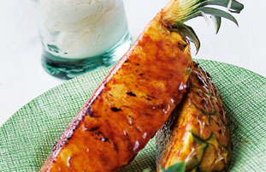

Serves 4 EASYPrep 10 mins Cook 10 mins

Serve hot Rum & Cinnamon Glazed Pineapple with cool vanilla ice-cream, an ideal dessert for hot sunny days and great for cooking on the barbecue.

Ingredients
- 25g (1oz) butter, softened
- 2 tbs rum
- 1 tbs brown sugar
- 2 tsp Schwartz Cinnamon Ground
- 1 medium pineapple

Method
STEP 1Make the glaze by mixing the butter, rum, sugar and Cinnamon together in a large bowl.
STEP 2Cut the pineapple lengthways into quarters and then cut each quarter in half, giving 8 wedges of pineapple.
STEP 3Brush the glaze over the pineapple wedges and barbecue or grill for 5 minutes on each side, brushing occasionally with the glaze.
STEP 4Serve with vanilla ice-cream.

